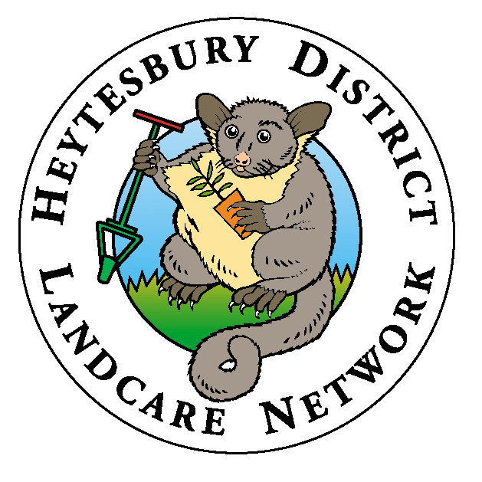

Individual Landcare Membership Form

FORM A

Becoming a member of a Landcare Group supported by the Heytesbury District Landcare Network (HDLN) offers many advantages. As a Landcare member you have access to the HDLN’s services and technical support, access to funding opportunities including the Network’s Expression of Interest process, you will be covered by insurance during Landcare activities, and you can share knowledge and experience with other like-minded people from your area.

Membership is compulsory for those who want to access the HDLN services and resources.

TO BECOME A MEMBER OF LANDCARE IN THE HDLN REGION…

STEP 1: Decide which option suits you best
There are three ways you can become a member of Landcare in the HDLN:

Option 1; Join an existing Landcare Group
If you live near one of the existing five Landcare groups in the HDLN region, you can join this group. The annual membership to join a Landcare group is between $20-$44 per household, depending on the group.

Option 2: Become a member of the HDLN (short-term option)
If there’s no Landcare group in your area you can join the HDLN until a group is formed in your area. Your membership to the Network will be reviewed annually & if there are enough interested people in your area, a new Landcare group can be established with HDLN support. The annual membership fee to is $44 per household (inc. GST) to cover insurance and administration costs.

Option 3: Start a Landcare group
If there’s no Landcare group in your area and there is enough interested people in your area, you can start a new Landcare group or re-establish an old group that has been in recession, with help from the Network. The group can be whatever you want it be: it doesn’t have to be called a ‘Landcare’ group, it can be as formal or as informal as you want it to be, and it can focus on one or many issues.

STEP 2: Join your chosen Landcare group or contact the HDLN
If you decide to join an existing Landcare group or HDLN (Options 1&2), you need to select which group/HDLN in the form, then send the form and corresponding membership fee to Heytesbury District Landcare Network, via post: PO Box 69, Timboon, 3268, or in person at Shop 1/47 Main St Timboon. Your membership will be forwarded to your chosen group. Please contact the group contacts below if you wish to find out more information, including meeting times and activities.
If you want to start a Landcare group (Option 3) you need to contact HDLN on (03) 55 983 755 to further discuss your options.

Landcare Group Contacts

1. Bostocks Creek and District Landcare Group
Contact: Anita Chivell
Ph: 0448 357 085

2. Curdies Valley Landcare Group 3. Elingamite-Cobrico Landcare Group
Contact: Thais Hardman Contact: Helen Langley
Ph: 0432 461299 Ph: 5595 4200

4. Newfield Valley Landcare Group 5. Princetown Landcare Group
Contact: Graeme Pascoe Contact: Neil Boxshall
Ph: 5598 6406 Ph: 5598 8169

Once we have received this form, you are now officially a member of a Landcare Group supported by the HDLN.

For further enquires contact us on (03) 55 983 755 / admin@heytesburylandcare.org.au / PO Box 69, Timboon. 3268

Individual Landcare Membership Form

NAME(S):
ADDRESS:
PHONE No:
E-MAIL:
Would you like us to notify you of upcoming Landcare events and funding opportunities via e-mail? | YES | NO

Please tick the membership option you choose:
OPTION 1: I want to join an existing group. Please make cheque out to group you are joining, or direct deposit details below in HDLN section.

Please tick which group you wish to join
Newfield Valley Landcare Group  $40 annually. |  | Bostocks Creek and District Landcare Group.  $30 annually
Curdies Valley Landcare Group  $20 annually. | Elingamite-Cobrico Landcare Group  $20 annually. | Princetown Landcare Group  $25 annually.
- OPTION 2: I want to join the HDLN - $44( inc GST)

Payment options: Cheques made payable to: Heytesbury District Landcare Network Inc or group name above. Or direct deposit. BSB: 633-000 ACC:204 970 453 REF: Include your name as payment reference. And forward membership form onto HDLN. This payment is per household for annual membership fees.
OPTION 3: I want to start a Landcare Group

Signature:
Name:
Date:

Membership needs to be renewed annually for you to continue to obtain the benefits Landcare provides to you

Please keep a copy of this form for your own records. The HDLN can copy this form if requested

Please contact the Heytesbury District Landcare Network on (03) 55 983 755 / PO Box 69, Timboon. 3268 admin@heytesburylandcare.org.au if you have any questions regarding this form or membership.
Compiled: July 2009 Updated: July 2023

